**PH SENSOR**

* Measurement of pH for aqueos solutions can be done with a glass electrode and a pH meter

1. **Specifications**:

**Type** :Sealed, gel-filled, polycarbonate body, Ag/AgCl

**Response time** :90% of final reading in 1 second in a buffer

**Temperature range** :5 to 99°C

**BNC Connector :**Yes

**Range** :pH 0–14

**Accuracy** :± 0.2 pH units

**Isopotential pH** :pH 7 (point at which temperature has no effect)

**Shaft diameter** :12 mm OD

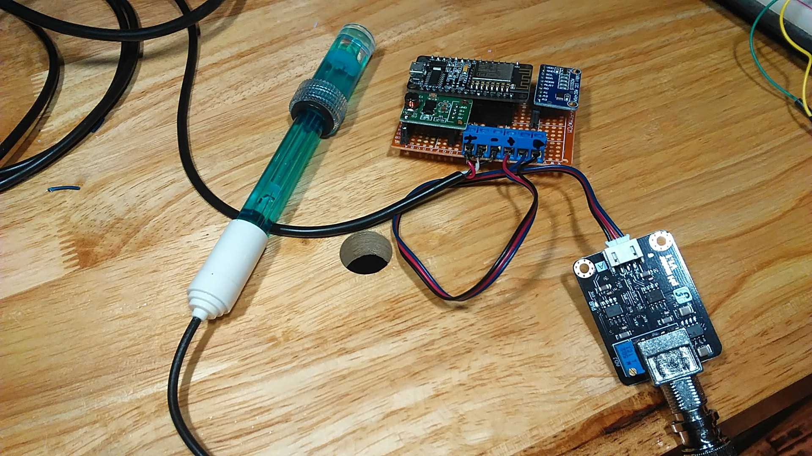

1. **How to use the PH SENSOR:**

pH probes must stay wet and cannot be allowed to dry out, this is why every pH probe is shipped in a plastic soaker bottle containing pH probe storage solution. The probe should remain in the bottle until it is used. If the probe is used infrequently, the bottle and its solution should be saved and the probe stored inside.

* Use an external switching power supply, and the voltage as close as possible to the +5.00V. More accurate the voltage, more higher the accuracy.
* Before using pH electrode, you need to calibrate it by the standard solution provided in sensor kit, in order to obtain more accurate results.
* The best environment temperature is about 25 ℃, and the pH value is known and reliable, close to the measured value. If you measure the acidic sample, the pH value of the standard solution should be 4.00. If you measure the alkaline sample, the pH value of the standard solution should be 9.18.
* Before the pH electrode measure different solutions, Cleaning of electrode using deionized water is recommended.

**Measuring pH**

1. Make sure that the meter is set to the pH Mode and adjust the temperature to 25°C.

2. Place the electrode in the sample to be tested.

3. The pH of the solution appears in the pH meter.

4. Rinse the pH electrode and place it back in the storage solution.

5. ADS1115 16bit ADC to convert the analog signal from the PH sensor to digital. DC voltage converter to handle the required 5v for the PH sensor (the ESP8266 is 3.3v)

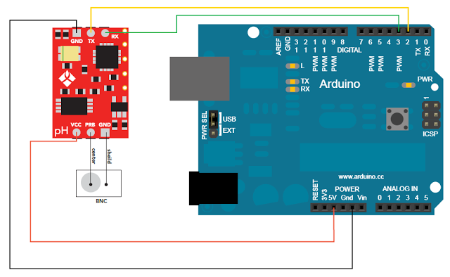

Connect pH sensor according to the circuit diagram, that is, The pH electrode is connected to the BNC connector on the pH sensor circuit board，and pH sensor board is connected to the digital pins 2 and 3 (software serial) of the Arduino controller.